* Dashboard
* Formatting
* Forecasting
* Trend Lines

A dashboard is a consolidated display of many worksheets and related information in a single place. It is used to compare and monitor a variety of data simultaneously. The different data views are displayed all at once. Dashboards are shown as tabs at the bottom of the workbook and they usually get updated with the most recent data from the data source. While creating a dashboard, we can add views from any worksheet in the workbook along with many supporting objects such as text areas, web pages, and images.

Each view you add to the dashboard is connected to its corresponding worksheet. So when you modify the worksheet, the dashboard is updated and when you modify the view in the dashboard, the worksheet is updated.

Creating a Dashboard

Using the Sample-superstore, let's plan to create a dashboard showing the sales and profits for different segments and subcategory of products across all the states. To achieve this objective we follow the below steps.

Step-1

Create a blank worksheet by using the add worksheet icon located at the bottom of the workbook. Drag the dimension Segment to the columns shelf and the dimension Sub-Category to the Rows Shelf. Drag and drop the measure Sales to the color shelf and the measure Profit to the Size shelf. This worksheet is referred as the Master worksheet. Right click and rename this worksheet as Sales_Profit. The below chart appears.

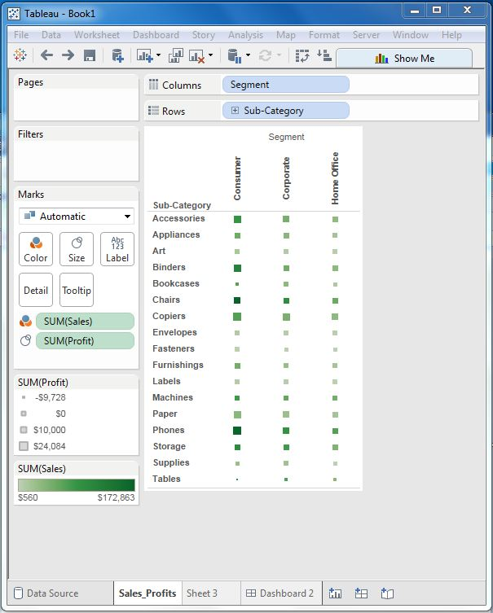

Step-2

Next we create another sheet to hold the details of the Sales across the States. For this we drag the dimension State to the Rows shelf and the measure Sales to the Columns shelf. Next we apply a filter to the State field to arrange the Sales in descending order. Right click and rename this worksheet as Sales_state. Follow the diagram below to create this sheet.

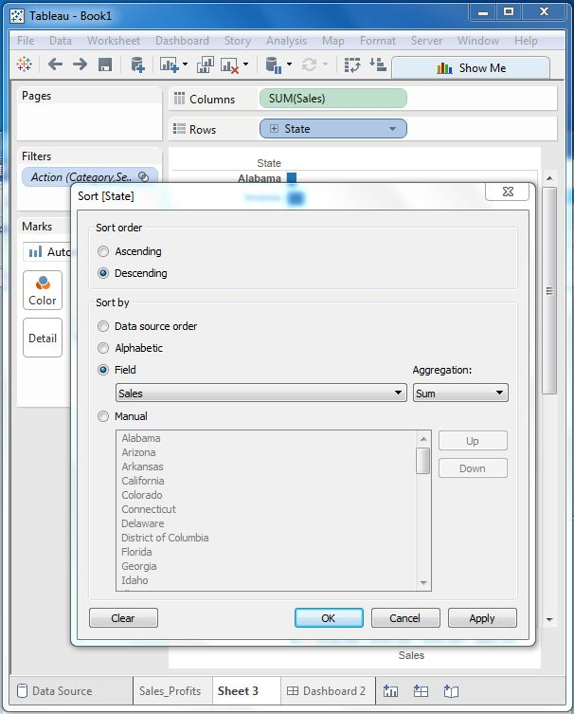

Step-3

Next we create a blank dashboard by clicking on the create new dashboard link at the bottom of the workbook. Right click and rename the dashboard as Profit-Dashboard.

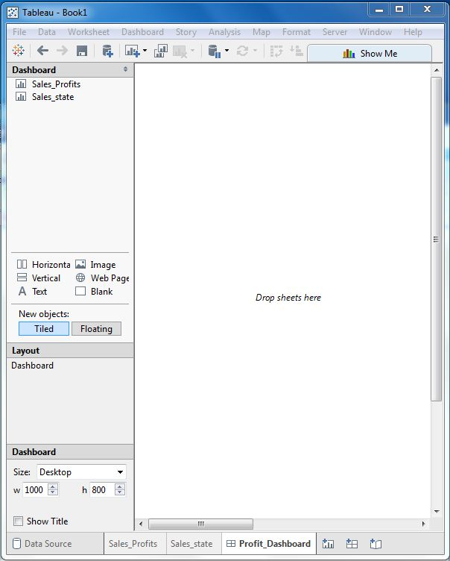

Step-4

Drag the two worksheets to the dashboard. Near the top border line of Sales Profit worksheet, you can see three small icons. Click on the middle one which shows the prompt Use as filter on hovering the mouse above it.

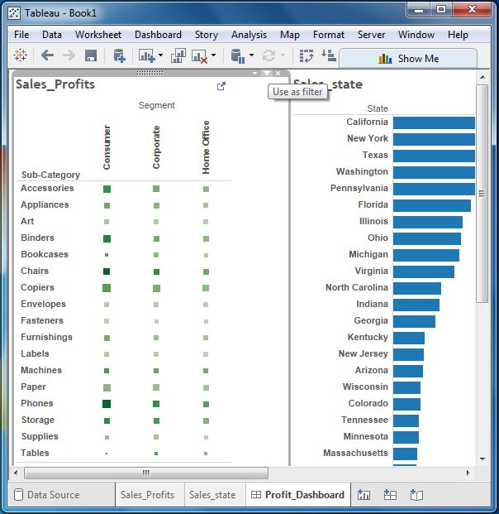

Step-5

Now in the dashboard click on the box representing Sub-category named Machines and segment named Consumer.

you can notice that only the states where the sales happened for this amount of profit are filtered out in the right pane named Sales_state. So this illustrates how the sheets are linked in a dashboard.

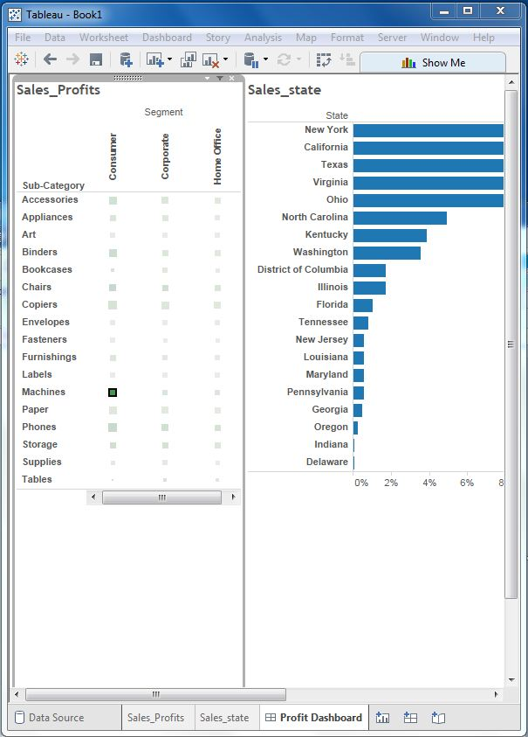

Tableau – Formatting

Tableau has a very wide variety of formatting options to change the appearance of the visualizations created. You can modify nearly every aspect like fonts, colors, size and layout etc. You can format both the content and containers like tables, labels of axes and workbook theme etc.

The below diagram shows the Format Menu which lists the options. We will touch upon some of the frequently used formatting options.

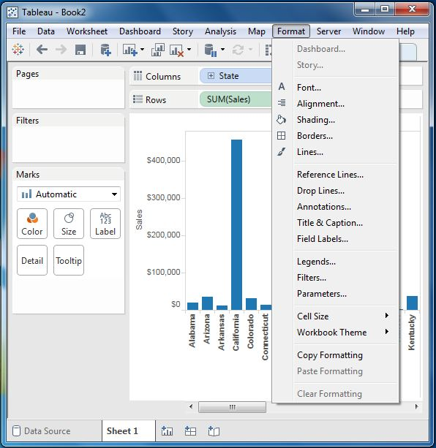

Formatting the Axes

Let’s create a simple bar chart by dragging and dropping the dimension Sub-Category into the Columns Shelf and the measure Profit into the Rows shelf. Click on the vertical axis and highlight it. Then right click it and chose format.

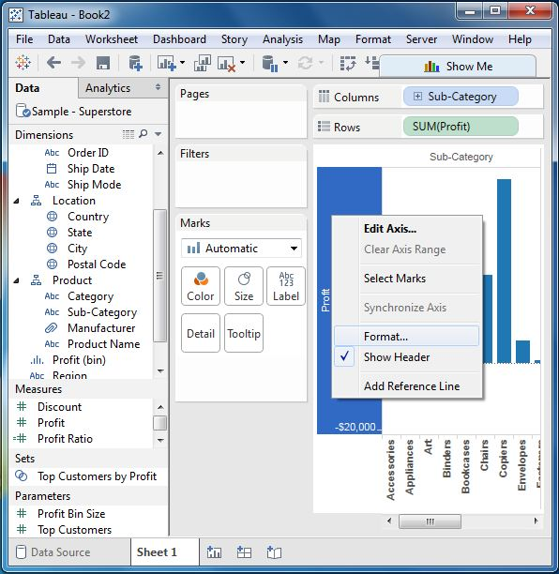

Change the Font

Click on the font drop down in the Format bar which appears in the left. We choose the font type as Arial and size as 8pt. as shown below.

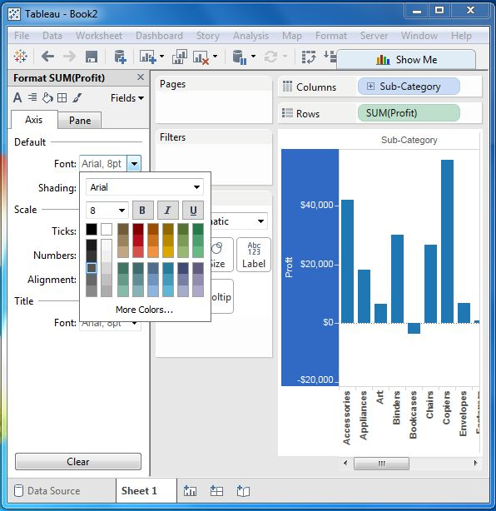

Change the Shade and Alignment

Next we can also change the orientation of the values in the axes as well as the shading color as shown below.

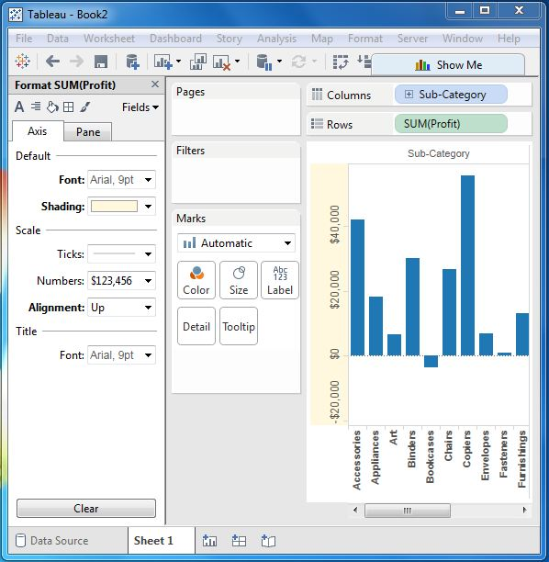

Format Borders

Let’s see a crosstab chart with Sub-Category in the Columns shelf and State in the Rows shelf. Now we can change the borders of the crosstab table created by using the formatting options. Right click on crosstab chart and choose Format.

The Format Borders appear in the left pane. Choose the options as shown below.

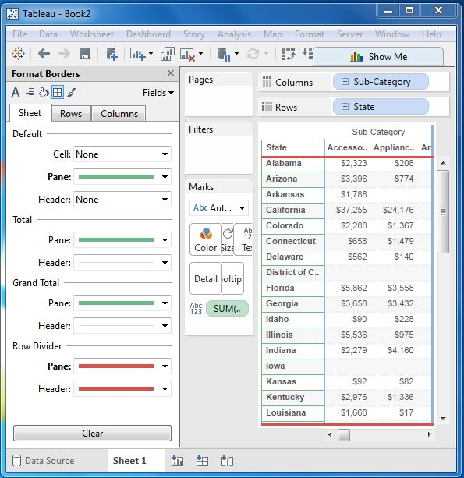

Tableau – Forecasting

Forecasting is about predicting the future value of a measure. There are many mathematical models for forecasting. Tableau uses the model known as exponential smoothing. In exponential smoothing, recent observations are given relatively more weight than older observations. These models capture the evolving trend or seasonality of the data and extrapolate them into the future. The result of a forecast can also become a field in the visualization created.

Tableau takes one time dimension and one measure field to create forecast.

Creating a Forecast

Using the Sample-superstore, let's forecast the value of the measure sales for next year .To achieve this objective we follow the below steps.

Step-1

Create a line chart with Order Date (Year) in the columns shelf and Sales in the Rows shelf. Go to the Analysis tab as shown below and click on Forecast under Model.

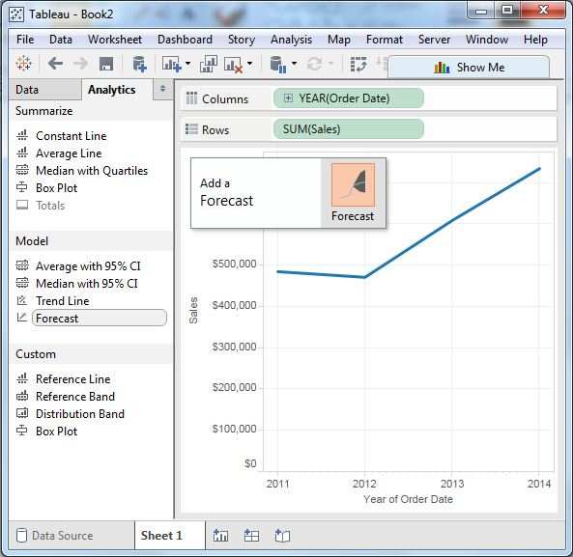

Step-2

On completing the above step we get the option to set various options for forecast. We choose the Forecast Length as 2 Years and leave the Forecast Model to Automatic as shown below.

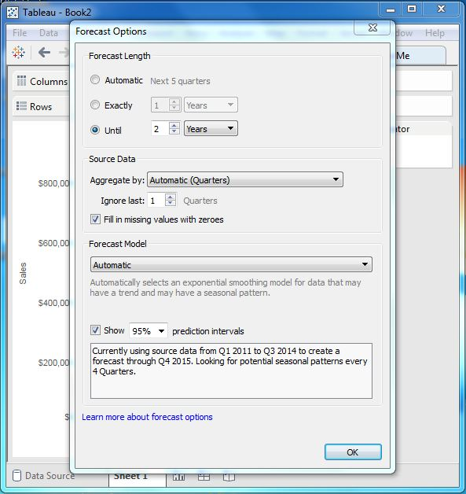

On completing the above steps we get the final forecast result as shown below.

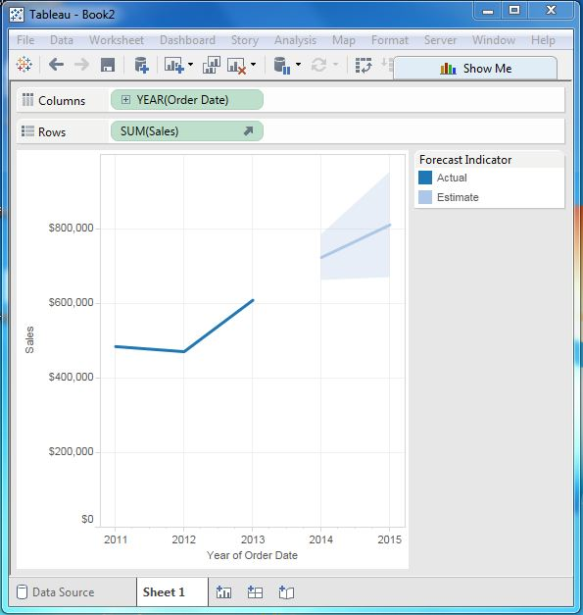

Describe Forecast

We can also get the minute details of the forecast model by choosing the option Describe Forecast. We get this option by right clicking on Forecast diagram shown above.

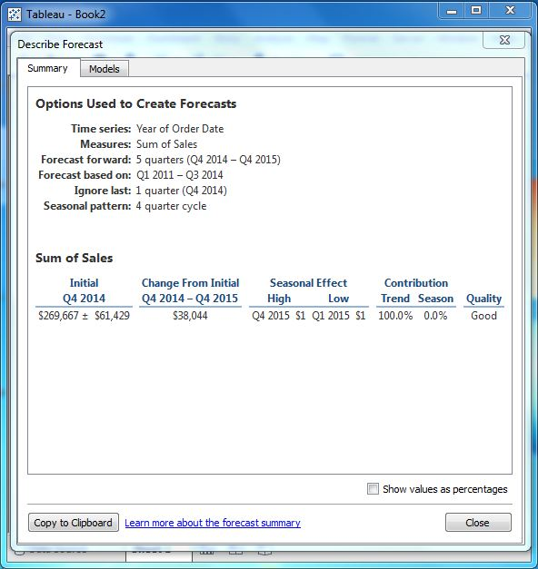

Tableau - Trend Lines

Trend lines are used to predict the continuation of certain trend of a variable. It also helps to identify the correlation between two variables by observing the trend in both of them simultaneously. There are many mathematical models for establishing trend lines. Tableau gives us four options. They are Linear, Logarithmic, Exponential and Polynomial. We will look into the linear model in this chapter.

Tableau takes one time dimension and one measure field to create a Trend Line.

Creating Trend Line

Using the Sample-superstore, let's find the trend for the value of the measure sales for next year .To achieve this objective we follow the below steps.

Step-1

Drag the dimension Order date to the column Shelf and the measure Sales to the rows shelf. Choose the chart type as Line chart. In the Analysis menu go to model -> Trend Line.Clicking on it brings up a pop up showing different types of trend lines that can be added. We choose the linear model as shown below.

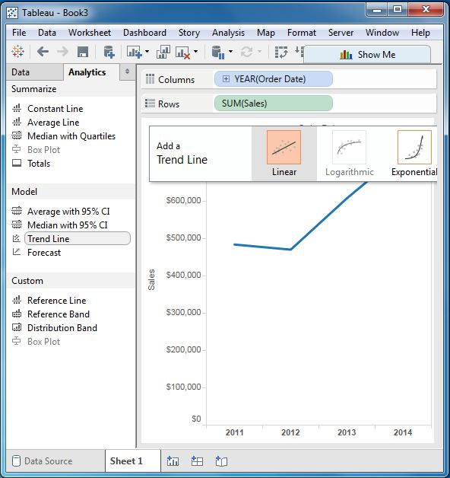

Step-2

On finishing the above step we get various trend lines. It also shows the mathematical expression for the correlation between the fields, the P-Value and the R-Squared value.

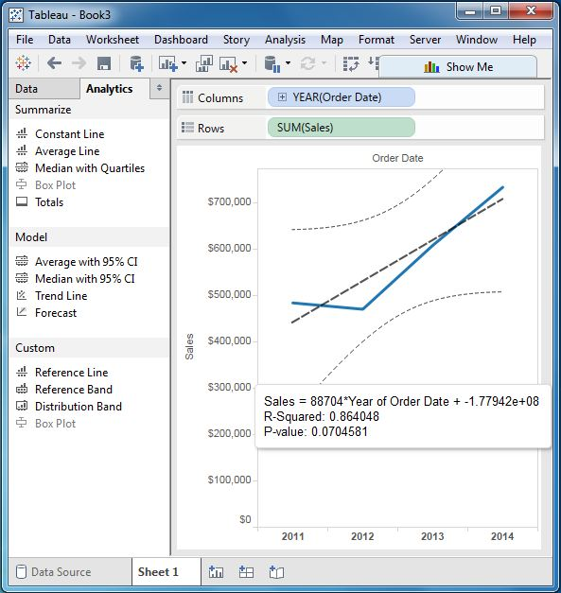

Describe the Trend Line

We can also get a very detailed description of the Trend Line chart by right clicking on the chart and selecting the option Describe Trend Line. It shows the coefficients, intercept value and the equation. These details can also be copied to clipboard and used in further analysis.

